University of Plymouth

School of Engineering, Computing, and Mathematics

COMP3000
Computing Project
2025/2026

Stronghold

Mark Hardy
10857365

BSc (Hons) Computer Science (Cyber Security)

Acknowledgements
I would like to thank my supervisor, Bogdan Ghita, for his continuous support throughout the development of this project and providing valuable feedback for improvements to the project.

Abstract
Most web browsers available on the market today are helpful at mitigating the risk of children encountering malicious content whilst browsing the internet. However, none of the available options are useful at teaching why content could be dangerous.
Stronghold is a security-focussed web browser, aimed at teaching children safe internet browsing behaviours. The intention of Stronghold is to act as a fun, educational tool which parents can rely on to keep their children safe whilst allowing them to learn about the dangers of the internet. Gamification aspects, such as a levelling system and challenges, are used to reward and encourage safe browsing behaviours like identifying potentially malicious site links and download types, while penalising users who attempt to access them.
Stronghold will act as a transitional web browser, where children can begin their journey on the internet while mitigating their risk of encountering malicious content in an enjoyable yet informative fashion.

Table of Contents

Acknowledgements 2
Abstract 2
Table of Contents 3
Table of Figures 6
Word Count 6
Code Link 6
1 Introduction 7
2 Background, Objectives, and Deliverables 7
2.1 Background 7
2.2 Literature Analysis 8
2.2.1 Online Threats 8
2.2.2 User Behaviour 9
2.2.3 Inexperienced Users 10
2.2.4 Existing Products 11
2.3 SMART Objectives 12
2.4 Deliverables 13
3 Design 13
3.1 Wireframes 13
3.1.1 Startup Page 14
3.1.2 Home Page 15
3.1.3 Dashboard 16
3.1.4 Taskbar 16
3.1.5 Settings Page 17
3.1.6 Blocking Page 18
3.1.7 Warning Page 19
3.2 Flowcharts 19
3.2.1 Risk Score Calculation 19
3.2.2 Download Blocking Process 19
3.2.3 Navigation Flow 19
3.2.4 Quiz Process 20
3.3 Use Cases 21
3.3.1 Load Website 21
3.3.2 Download File 21
3.3.3 Guest User Browsing 21
3.3.4 View Feedback 22
3.3.5 Typosquatting Detection 22
3.3.6 Phishing Detection 22
3.3.7 TLS Certificate Validation 22
3.4 Unique Selling Points 22
4 Method of Approach 23
4.1 Risk Assessment 23
4.2 Agile Method 23
4.3 Tools and Technologies 24
4.3.1 JavaScript 24
4.3.2 Electron 24
4.3.3 Visual Studio Code 24
4.3.4 Firebase 24
4.3.5 Devices 24
4.3.6 HTML and CSS 25
4.3.7 Figma 25
4.4 Risk Score Calculation 25
4.4.1 HTTP Check 27
4.4.2 Domain Name Check 27
4.4.3 Domain Age Check 30
4.4.4 Security Header Check 30
4.4.5 Typosquatting Check 34
5 Implementation 36
5.1 Features 36
5.1.1 Session Only Cookies 36
5.1.2 Cookie Export Authentication 36
5.1.3 Blocking of Non-HTTPS Sites 37
5.1.4 Blocking Downloads 37
5.1.5 TLS Certificate Checking 38
5.1.6 Security Based Hints 38
5.1.7 Override Methods 38
5.1.8 Quiz System 39
5.1.9 Guest Browsing 39
5.1.10 Security Dashboard 39
5.2 Firebase 40
6 LSEP Considerations 41
6.1 Legal Issues 42
6.2 Social Issues 42
6.3 Ethical Issues 43
6.4 Professional Issues 43
7 Project Management 44
7.1 Sprints 44
7.1.1 Sprint 1 44
7.1.2 Sprint 2 44
7.1.3 Sprint 3 44
7.1.4 Sprint 4 44
7.1.5 Sprint 5 44
7.1.6 Sprint 6 44
7.1.7 Sprint 7 44
7.2 Trello 44
7.3 GitHub Desktop 45
8 Testing and Evaluation 45
8.1 Testing Methodology 45
8.2 Functional Testing 46
8.3 User Testing 47
8.4 Evaluation 48
9 Future Implementations 48
9.1.1 DNS Check 48
9.1.2 Redirect Analysis 48
9.1.3 Parental Controls 48
9.1.4 AI Chatbot 49
9.1.5 Built-in VPN 49
10 Conclusion 49
11 References 49
12 Appendices 51
12.1 Appendix A – Design Screenshots 51

Table of Figures

Word Count
Words –

Code Link
GitHub – https://github.com/Mark7567/COMP3000

Introduction
This report will discuss the creation of a security-focussed web browser titled ‘Stronghold’. The purpose of this project is to teach children how to browse the internet safely, utilising behavioural conditioning and gamification aspects to do so. The project was initially targeted towards the elderly due to their high presence as victims of malicious attacks such as phishing, however the decision to implement gamification led to a pivot to a target audience of young children who may benefit more from learning about internet safety before using less safe, unrestricted internet browsing. Leaning towards behavioural conditioning then felt to be the best pivot since children may be more responsive when using positive reinforcement and structured feedback techniques. The project will finalise in a browser that aims to reduce risks and encourage safer browsing behaviour.
The report will cover the initial design that had been planned for implementation, including wireframes, storyboards, flowcharts, and use cases for each initial page and feature, the methodology behind the development lifecycle, the main features that were both planned and implemented in the final design, the unique selling points that make the browser different from other products, the testing that was performed on the initial designs, including how testing was performed and how the results of testing influenced future decisions, the issues and challenges that could potentially have been faced throughout development, as well as those that were actually faced, and a final conclusion discussing the overall thoughts and feelings surrounding the project as a whole.

Background, Objectives, and Deliverables

Background
As children gain access to the internet from younger ages, it is important to ensure that they have knowledge of potential threats they may face, while also keeping them safe when online. The increase in cyber threats such as phishing heighten the importance of learning safe browsing practices, especially while young and therefore susceptible to behavioural changes.
Traditional browsers such as Google Chrome or Microsoft Edge are acceptable solutions for keeping high security standards and allowing children to remain safe while browsing online; however, these solutions do not teach users why their behaviour is unsafe, meaning they are susceptible to performing it repeatedly and developing unsafe browsing behaviour. Warnings are often also passive and can be easily ignored or misunderstood by users. As a result, a solution is needed to not only protect users from online threats, but to help them understand why a website or a download may be unsafe.
Stronghold aims to act as the solution by utilising behavioural conditioning to establish safe browsing habits within children while ensuring their safety online. A risk score is calculated for each website a user attempts to access, combining a multitude of factors such as domain structure analysis and typosquatting prevention to determine whether a site is safe to access. By combining constructive feedback with a punishment and reward system, this aims to improve both user safety and awareness of threats when online.

Literature Analysis

Online Threats
The modern internet contains a wide range of threats that should be considered when determining user safety. The 2024 Data Breach Investigation Report by Verizon highlighted that the most common attack vector was exploiting credentials, with the most common access point being web applications. The report also identifies additional attack vectors including phishing, denial of service, and exploiting vulnerabilities, demonstrating the vast number of threats that a user may face while online and therefore need to be prepared for.
Malware remains a significant risk to internet users, particularly through compromised websites and unsafe downloads. Guidance from the National Cyber Security Centre details steps that can be taken to mitigate the risk of a malware infection; although this relates primarily to organisations, guidance equally applies to individual users. The guidance highlights the importance of having correct malware protection in place to reduce the likelihood of an infection occurring by blocking access to downloads onto the device.
Many threats posed rely heavily on manipulation and user deception rather than purely technical methods. Research from Zscaler (2024) highlighted the dangers of typosquatting and brand impersonation to manipulate users into accessing malicious domains. Typosquatting is often combined with other malicious methods such as phishing, credential theft, or malware delivery to increase the likelihood of a successful attack. The research also discovered that over half of phishing domains utilised free TLS certificates which in turn allowed them to bypass traditional browser security. This demonstrates that indicators such as possession of a TLS certificate are not a sufficient way to determine the safety of a website as it can enhance credibility of sites possessing one.
The research also observed that typosquatting domains could be used to initiate an automatic download of malicious payloads, such as trojans. This highlights the importance of considering file-based threats alongside domain-based threats when deciding security features.

User Behaviour
Research has revealed that users are not always responsive to security warnings that appear on browsers when dangerous actions are being performed. A study performed by Sunshine et al. (2009) found that many users portrayed dangerous behaviour by ignoring warnings, both that were premade by browsers such as Firefox and Internet Explorer, and warnings created by the conductors of this study. The conclusion of this study revealed that blocking users from unsafe websites and eliminating warnings would be a more suitable method. This study is limited however by its age, as it contains details and uses warnings present in older internet applications, which are no longer present. This study did contain many participants, with 100 participants being involved, which supports statements made in the study; however, the participants involved were all adults which may not correctly reflect browsing habits within children. Despite these limitations, the study highlights an important issue: users may not reliably respond to warnings and require access from malicious sites being blocked. Stronghold aims to tackle this by utilising warnings on medium risk sites and blocking access completely to high-risk sites.
A significantly larger study containing over 6,000 participants was conducted by Reeder et al. (2018). This study identified that while a proportion of users do adhere to warnings, a significant number ignore them or fail to comprehend their meaning. A lack of comprehension influenced user decisions more than habituation, although this played a small role. This suggests that even when warnings are adhered to, user knowledge is not increased and there is no improvement in understanding the risk. This is vital for younger users who may lack the knowledge to understand security messages; this is something Stronghold aims to resolve through gamification and specialty quizzes, as well as messages alongside the warnings.
Further research conducted by Vance et al. (2017) revealed that users habituated to warnings over a five-day workweek, making them more likely to ignore the warnings as they habituated. The study compared both static and polymorphic warnings, with the study concluding that polymorphic warnings improved users’ responses to important security messages. This study is also limited by its age slightly, however due to its focus being on habituation, this does not apply as harshly as studies primarily focussing on the internet. Additionally, this research involved only 16 participants, all of whom were adults within a work environment. Findings from this study do however support the idea that repeated exposure reduces the effectiveness of warnings, which presents a challenge to systems that rely on warnings. Stronghold was able to adapt from this by utilising a mixture of blocking and warning to encourage learning and reduce the likelihood of warnings becoming ignored.
This concept is additionally supported by a study conducted by Kirwan et al. (2020) who used an MRI scanner to examine the neurological responses to repeated exposure. The study found that repeated exposure reduced stimulus processing and attention, indicating that users become desensitised and fatigued to constant exposure. While the overlap in authors compared to the previous study limit the available perspectives, the use of neuroscientific methods strengthens the validity of the findings. This suggests that how users process warnings may extend beyond conscious decisions due to the existence of fatigue, which has influenced Stronghold to alter the warning pages by stating the reasons for why the warning has appeared, alongside adjusting between URL warnings and download warnings.

Inexperienced Users
A study conducted by Ofcom (2024) revealed that a vast majority of children use technological devices, with finding online images and playing games being some of the most common activities performed. This reveals that children are getting involved in online environments from a young age and therefore are exposing themselves to potential risks due to their inexperience.
While the study highlights the increase in internet usage among children, it fails to identify that younger users may not have the experience to keep themselves safe while online by verifying domains and avoiding malicious downloads for example. This creates a greater reliance on external systems to allow for online safety while navigating online.
Furthermore, the study found that parents recognise that the internet is a learning space for their children, suggesting that online environments should allow for both safety and education. This reinforces the idea that only blocking unsafe content may not be suitable for developing long-term behaviours, and there is instead a need for systems that encourage learning while developing safer browsing habits.

Existing Products
Modern existing products such as Google Chrome, Microsoft Edge, Mozilla Firefox, and Opera often include built-in security mechanisms to prevent or restrict access to malicious sites and downloads by utilising phishing protection, malware protection, and blacklisting sites flagged as dangerous. Tools such as Google Safe Browsing and Microsoft Defender SmartScreen are used to perform these tasks, reducing the likelihood of a user accessing threatening content.
While protection provided by these systems is known to be effective, they do not assist in improving understanding of threats faced. Users are typically blocked from accessing their content but receive a limited explanation as to why, causing a reliance on blocking without understanding how to improve browsing behaviours.
Furthermore, these systems are reactive, utilising databases of known threats instead of being proactive and analysing a domain’s characteristics when the user attempts to access it. This may limit their ability to block new threats or more complicated techniques such as typosquatting.
This highlights a gap in the market where a solution is required to enforce learning techniques while providing a safe system. Combining education with security allows users to remain safe while understanding what they are being kept safe from.

SMART Objectives
The primary objectives of this project were defined using the SMART framework to ensure they were specific, measurable, achievable, relevant, and time bound. The objectives are outlined as the following:
- To design and develop a functional, security-focussed web browser using the Electron framework which allows for basic navigation and searching of both URLs and queries within 5 seconds of opening the browser
- To take appropriate action of either warning against or blocking suspicious URLs based on a risk scoring system and depending on the user’s security settings within 2 seconds of the URL being searched or selected from a Google search query to prevent access to the site and instead display the relevant page explaining reasons for the action
- To implement a tiered download prevention system which intercepts and blocks or warns against downloads with commonly malicious extensions within 1 second of the download being processed to ensure malicious downloads do not get installed on user devices
- To implement a dashboard page which is linked to Firebase and displays a user’s current level, experience points, blocked URLs, blocked downloads, ignored warnings, and recent changes, which update within 5 seconds of a relevant user action being completed.
- To create a daily quiz containing 1 question that a signed-in user can access and complete within 2 minutes to receive a reward of 10 experience points if the correct answer is chosen
- To create a weekly quiz containing 10 questions that a signed-in user can access and complete within 5 minutes to receive a reward of 5 experience points per correct answer, with a total of 50 experience points being available
- To implement Google OAUTH sign in connected to Firebase which allows a user to sign in with their Google account and view their statistics and settings within 3 minutes

Deliverables
The final deliverables expected from this project are:
- A working prototype for an Electron-based browser
- This 10,000-word report documenting the creation of this project
- A 5-minute video to demonstrate the features of this project
- A GitHub repository containing necessary code for the project to function
- A non-technical poster to explain the purpose of this project

Design
This section showcases the design decisions made throughout the development of this project. It works through both UI design and feature design, detailing the initial wireframes and flowcharts used to plan each page, how the final implementation compared to these designs, and features and unique selling points which were planned, explaining why each feature was deemed necessary, how it was intended to be implemented, and whether it was included in the final project or not.

Wireframes
The initial wireframes were designed using Figma to create an understanding of button layout, colour options, and basic user flow which is expanded on with flowcharts. Due to the target audience for this project being children, the designs focussed on simplicity and providing an easy understanding of how to use the browser. Each wireframe acted as a visual plan to receive feedback on before the final design was implemented. Several elements of each page were added, changed, or removed based on this user feedback and constraints with development.

Startup Page
Figure 1 – Wireframe for Stronghold startup page

Figure 1 shows the wireframe for the startup page. This page was designed to be the starting point for the browser, providing the user with the option to sign into an account where they could track security statistics and customise their experience, or browse as a guest with the strictest security options enabled and no gamification. The initial design was simple, containing only a Google sign-in button and a guest browsing button.


Home Page
Figure 2 – Wireframe for Stronghold home page
Figure 2 shows the wireframe for the home page. This page was designed to be the central point that the user would see after signing in or when a new tab was opened. The design was kept simple, providing the user only with the option to enter a URL or search query into the search box.

Dashboard
Figure 3 – Wireframe for Stronghold dashboard
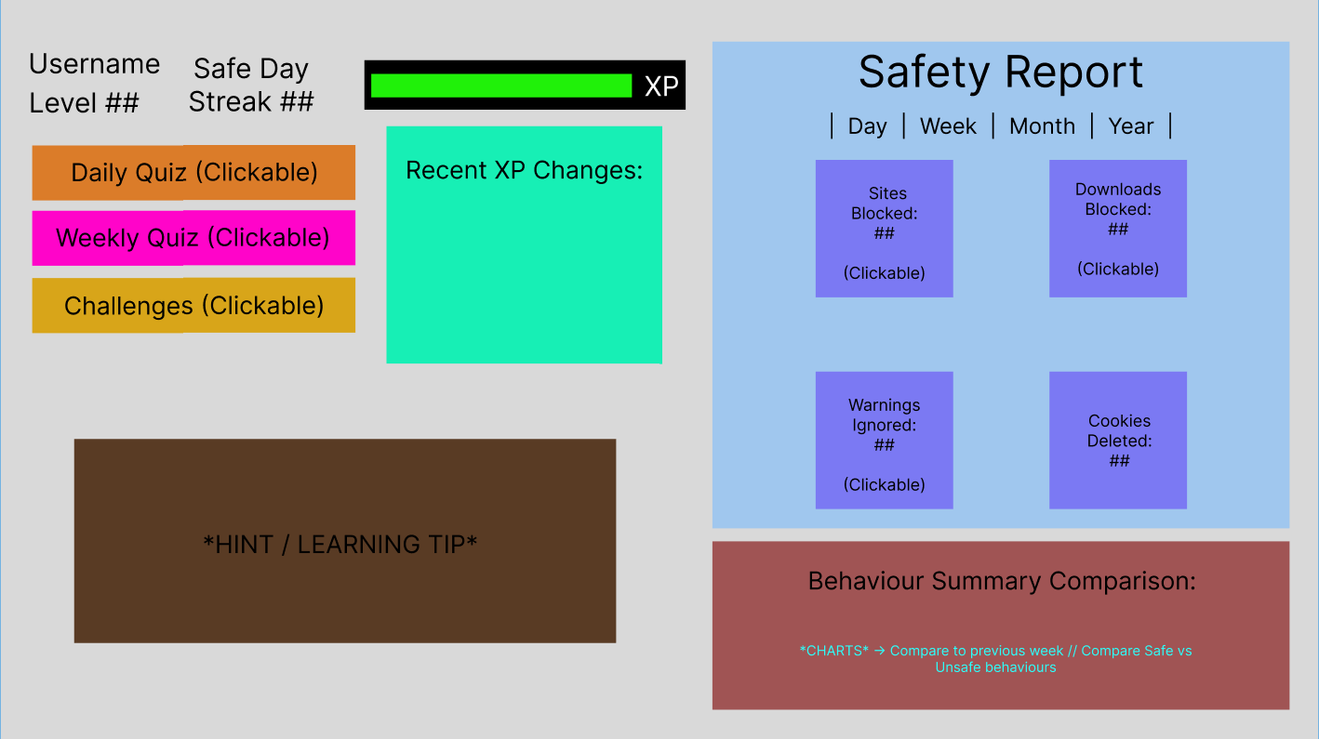
Figure 3 shows the wireframe created for the dashboard. This page was designed to be the centralised point for all gamification elements of the browser, containing features such as a safety report for browsing which tracked blocked sites, blocked downloads, warnings ignored, and cookies deleted. The dashboard wireframe also contained a behaviour summary, hints and tips, quizzes and challenges, and experience point logic such as the levelling system and recent changes to experience. This was a much more complicated design as this was the page intended to encourage the behavioural conditioning and learning elements of the browser.

Taskbar
Figure 4 – Wireframe for Stronghold taskbar
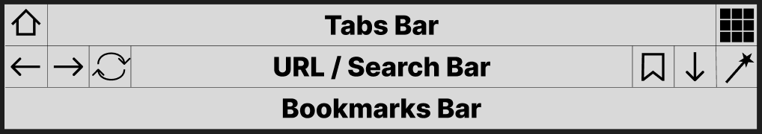
Figure 4 shows the wireframe created for the taskbar. This page was designed to be constantly displayed, allowing the user to enter a URL or search query into the search bar, access other relevant pages such as the home page, dashboard, and settings page, display recent downloads, allow pages to be bookmarked and displayed, and act as a general form of navigation for the browser. The initial design was slightly complicated due to the limited space, requiring a small addition to the top of each page, and the number of features needing to be implemented in that small space.

Settings Page
Figure 5 – Wireframe for Stronghold settings page
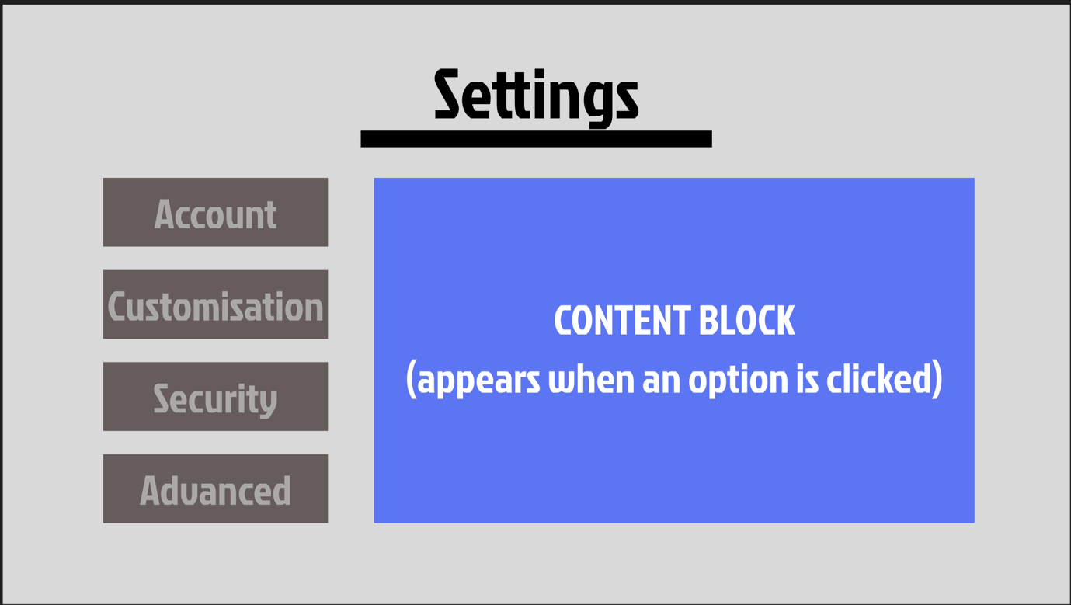
Figure 5 shows the wireframe for the settings page. This page was designed to allow the user to adjust a variety of settings for the browser, such as their theme, account details, and security settings. The initial design remained simple, relying on a changing content block to display the actual settings options based on the category selected by the user.

Blocking Page
Figure 6 – Wireframe for Stronghold blocking page
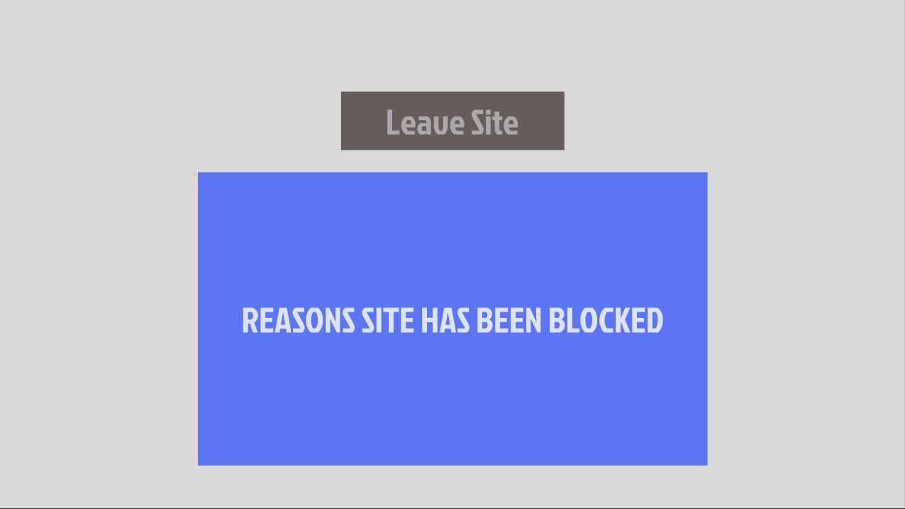
Figure 6 shows the wireframe for the blocking page. This page was designed to be simple and explain the reasons why a URL was blocked with an option to return to the previous page. This page was not intended to give the user the option to continue to the page was it was planned to be used only against incredibly high-risk pages.

Warning Page
Figure 7 – Wireframe for Stronghold warning page
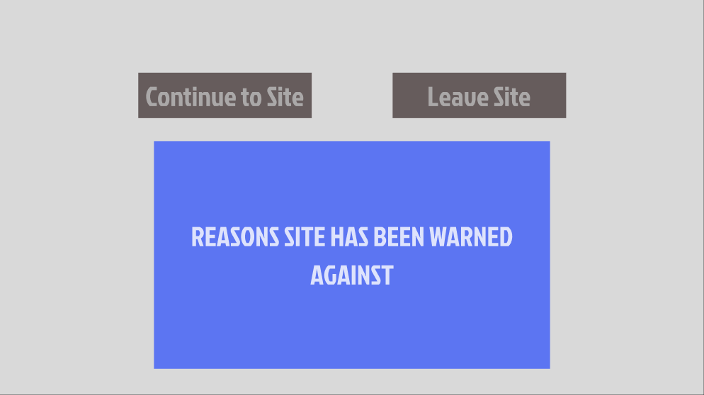
Figure 7 shows the wireframe for the warning page. This page was designed to be simple and explain the reasons why a URL was warned against with an option to return to the previous page or continue to the page trying to be accessed. was planned to be used only against medium risk pages that could be malicious but also contained many legitimate features.

Flowcharts

Risk Score Calculation

Download Blocking Process

Navigation Flow

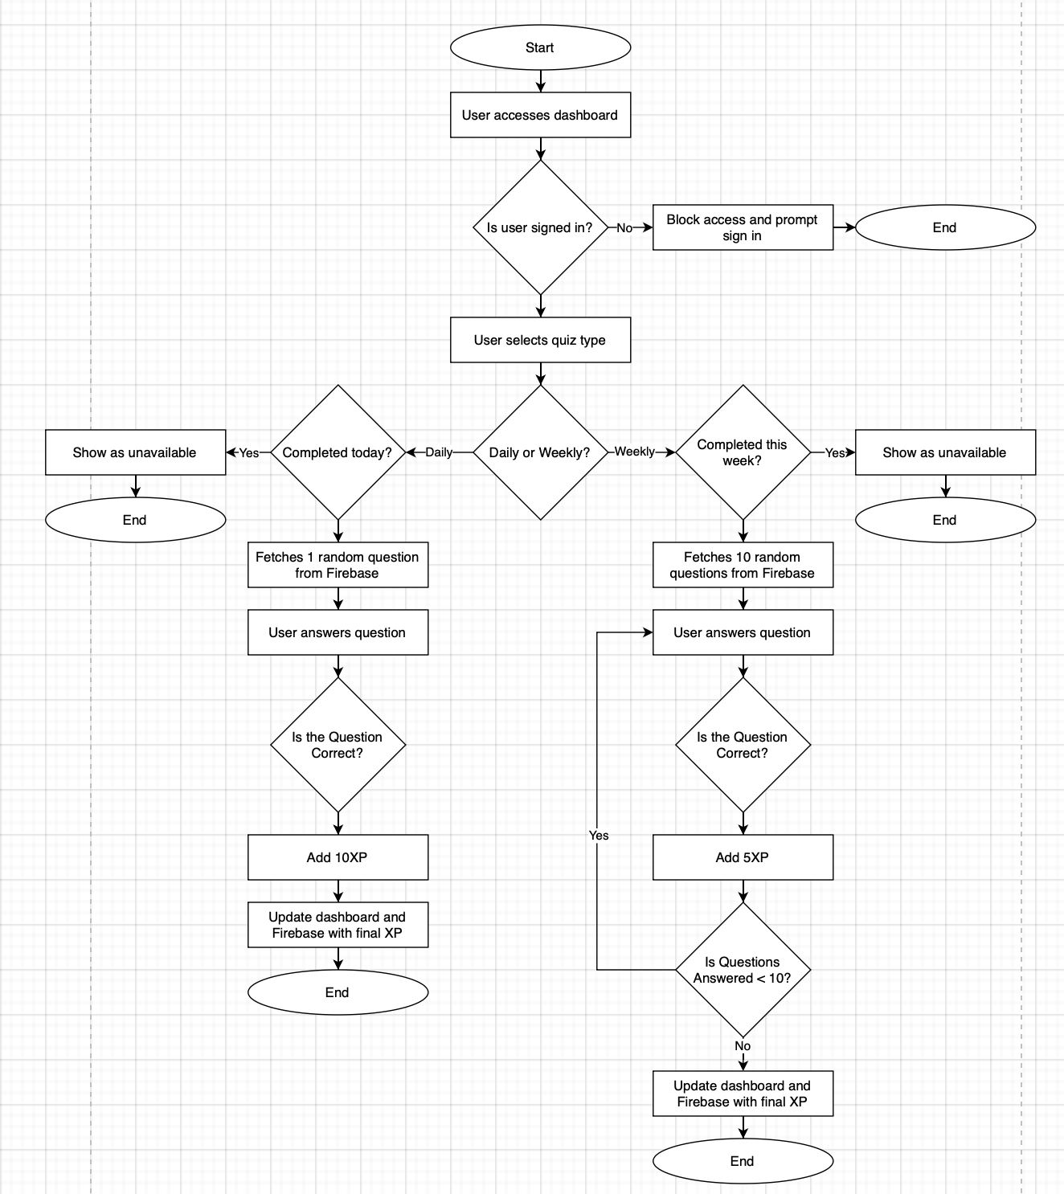
Quiz Process
Figure 8 – Flowchart for Quiz Process
Figure 8 shows the flowchart for the quiz process. [WRITE AN EXPLANATION!]

Use Cases

Load Website
- The user enters a website URL in the search bar, or clicks on a URL from a search query
- The system analyses the URL format if it is manually typed by the user to ensure it is valid
- Before loading the page, the system checks the URL for a user-determined risk score
- If the URL is deemed as safe, it is loaded
- If the URL is deemed as potentially malicious, a warning page is loaded, explaining the reasons for the warn and allowing an override onto the website
- If the URL is deemed dangerous, a blocking page is loaded, explaining the reasons for the block with no override options

Download File
- The user clicks on a download link from a website
- The system intercepts the file before the download can begin
- The file is analysed based on its extension and the user’s customised risk profile
- If the download is deemed safe, it is allowed and stored in the user’s downloads folder
- If the download is deemed potentially risky, the user is shown a warning (if enabled) with the reason why and an override
- If the download is deemed dangerous, it is blocked (if enabled) and the user is shown the reason why with no override

Guest User Browsing
- The user wants to browse without signing in
- The user clicks on guest browsing button upon opening browser
- The user gains restricted access to the browser, with strict URL and download protection settings enabled
- Access to dashboard and settings menu are restricted behind a login

View Feedback
- The user accesses a site with a high-level risk score
- The website is warned or blocked, displaying the relevant page to the user
- The page displays the overall risk score along with the specific reasons for the warning or blocking of the site
- User gains a better understanding of why they should not be accessing that website to improve their browsing security in future

Typosquatting Detection
- The user attempts to access a malicious website with a URL close to a legitimate one
- The system compares the URL with a pre-defined list of similar domain names using the Damerau-Levenshtein algorithm
- The risk score is increased based on similarity, with the reason being added to the warning or blocking page if displayed

Phishing Detection
- The user attempts to access a malicious website with a URL that contains commonly used phishing words
- The system compares the URL to a pre-defined list of phishing words
- The risk score is increased if a phishing word is detected, with the reason being added to the warning or blocking page if displayed

TLS Certificate Validation
- The user attempts to access a website without a valid TLS certificate
- The system checks for a certificate and analyses its validity
- The system blocks the website and displays the blocking page with the reason

Unique Selling Points
Stronghold contains a variety of unique features which differentiates it from traditional web browsers like Chrome or Edge, focussing on education over background protection. Behavioural conditioning is used by encouraging positive behaviour and punishing negative behaviour by manipulating experience points; this is something that other browsers do not provide.
Key features which provide a unique addition to Stronghold include the centralised dashboard which details the user’s security actions, a reward-based levelling system where the user’s experience level is increased or decreased based on their browsing actions, and interactive security-focussed quizzes designed to reinforce the information learned while browsing. These features aim to take a simple background feature for other browsers and turn it into a learning experience helping to keep younger people safer while online.

Method of Approach
This section will discuss the methodology used throughout the development of the project, explaining the architecture used to develop this project, including for the main code and the database, the decision making behind some of the core security features, and a discussion on future enhancements which could be made to the browser.

Risk Assessment

Agile Method
The agile method was selected as the main development approach for this project due to the constant change in requirements, and the abundance of features needing to be developed, including general browser navigation, Firebase connection, a risk scoring system, a quizzing system, and a gamified dashboard. Using an iterative method like agile allowed for features to be developed, tested, and redesigned within allocated slots, to allow full focus into that feature.
Development was divided into sprints, starting with a focus on planning, research and design, and later moving into feature development and implementing core functionality. Trello was used to track these sprints by planning tasks that should be completed within them, and marking off which tasks had been completed after the sprint was over.
Due to the lack of a development team, a full agile scrum method was not used; however, fortnightly meetings were arranged with a project supervisor to outline what had been completed, and what the next steps were for this project. This was useful to receive feedback on features and determine any changes which needed to be made, for example implementing a full risk score calculation over just blocking HTTP sites.
Overall, an agile method of development was important for receiving consistent feedback on implemented features and allowing for time to be focussed primarily on specific features to complete them to the highest level.

Tools and Technologies

JavaScript
JavaScript was the predominant language used for the creation of technical features within this project, as well as the standard navigation. This worked alongside many built-in Electron commands.

Electron
Electron was the main framework used for this project. Electron is a Chromium framework which, when used alongside JavaScript, allows for the creation of apps by utilising certain events and renderers to allow for navigation and other browsing features to be implemented.

Visual Studio Code
Visual Studio Code was the IDE of choice for the creation of this project due to having prior experience with this IDE in past projects, and it already being configured on the devices used for this project.

Firebase
Firebase was the platform of choice to host the database for this project due to its ability to automatically hash passwords, which is vital for ensuring security, and allowing for Google OAUTH authentication to be used for a single sign on into the browser.

Devices
Both a Windows desktop PC and a MacOS laptop were used throughout development of this project. This allowed for cross-platform development, and assurance that this project would work on multiple devices. No Linux devices were used due to not being accessible at any point in development.

HTML and CSS
HTML was used to create the browser-specific web pages, those being the home page, dashboard, settings menu, taskbar, and warning pages. CSS was then used to design and style these HTML pages.

Figma
Figma was used to create the initial wireframe designs for this project which acted as a guide for when implementing the first draft of the HTML and CSS.

Risk Score Calculation
A risk score was calculated whenever a user attempted to access a website, which determined how secure the website was and therefore whether access should be granted, a warning should be provided, or access should be blocked. Figure 8 shows the code for the function ‘riskScore()’.
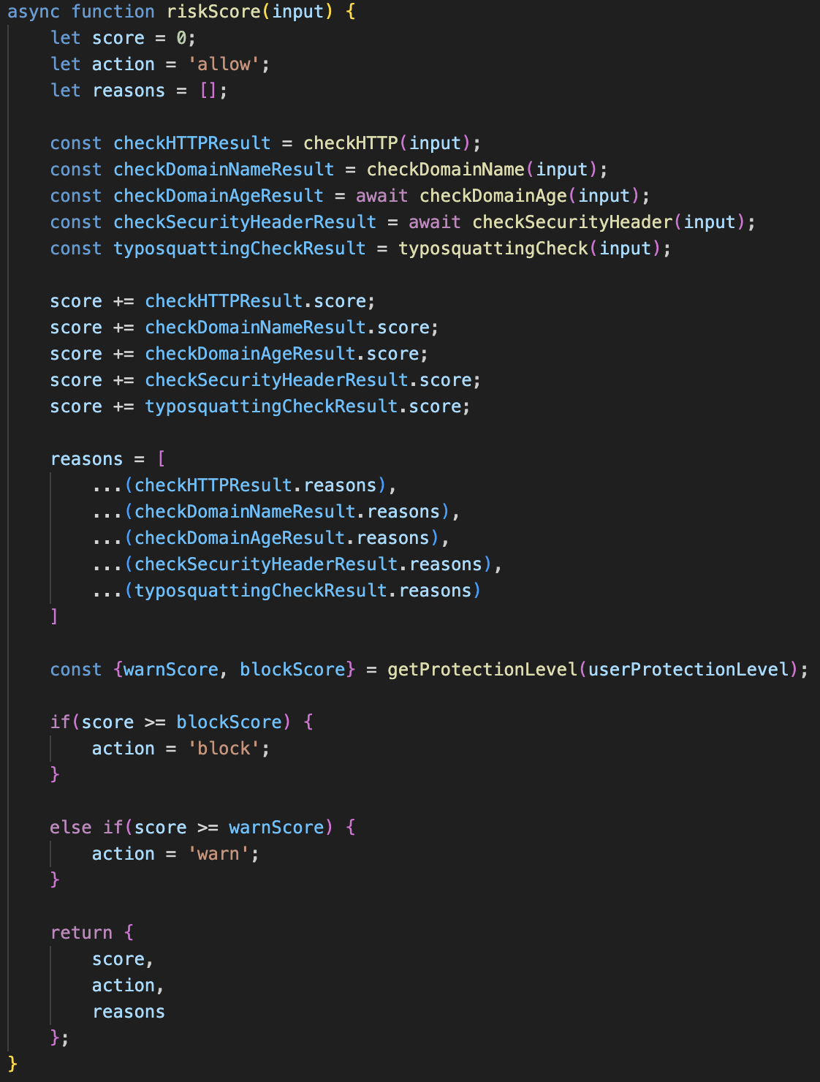
Figure 9 – The riskScore() function integrated in Visual Studio Code
The risk score function was comprised of multiple checks which culminated in a total score that determined the safety of the site, applying an event based on the result before the site was loaded. The features used for the risk score were:

HTTP Check
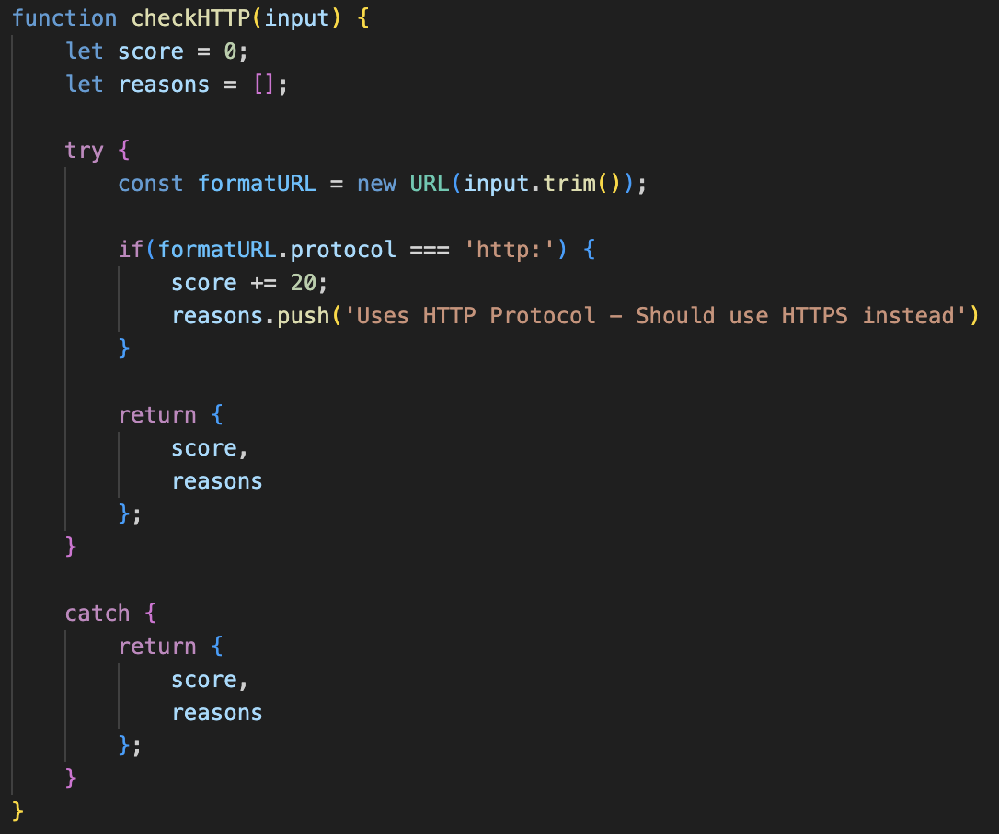
Websites utilising HTTP over HTTPS are flagged as a higher risk due to the lack of secure encryption on the site, increasing the risk score by 25 points. Figure 9 shows the code for the function ‘checkHTTP()’. While this is not necessarily indicative of a malicious site, the increase in risk score is in place since users should not be entering login details on these pages due to them being sent to the web server in plaintext, which can risk interception.
Figure 10 – The checkHTTP() function integrated in Visual Studio Code

Domain Name Check
A domain name checking function was implemented to determine whether a URL contains characteristics frequently hinting to malicious behaviours. This involved extracting the domain name from the URL and comparing it to multiple pre-determined risk factors. Figure 10 shows the code for the function ‘checkDomainName()’. Table 1 shows which risk factors were considered to determine if a domain may be malicious.
Table 1 – Domain Name Check Risk Factors
Factor | Condition | Score Adjustment | Reason
Phishing Words | Contains phishing words i.e. ‘login’, ‘secure’, or ‘verification’ | +10 points | Commonly used to imitate legitimate services and deceive users
Repeated Hyphens | Contains multiple hyphens in a row | +5 points | Used to replicate legitimate domains
Long Domain Name | Domain name exceeds 50 characters | +10 points | Can blend in malicious pathways and avoid traditional security filters
IP Address | URL is an IP address | +30 points | Conceals domain name and may indicate a maliciously hosted server
Homograph Attack | Contains punycode ‘xn--' | +30 points | Exploits similar looking characters to impersonate legitimate domains
@ Symbol | Contains ‘@’ | +20 points | Obscures destination by placing it after a legitimate domain
Multiple Dots | Contains three or more dots | +5 points | Enables subdomain manipulation to imitate legitimate domains

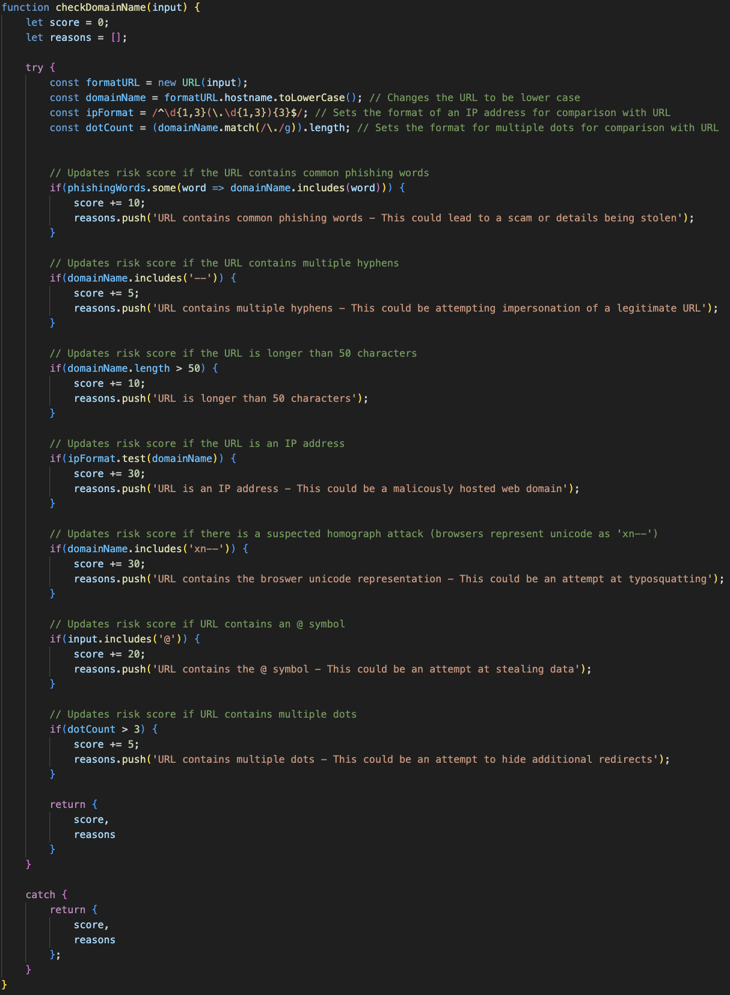
Figure 11 – The checkDomainName() function integrated in Visual Studio Code

Domain Age Check
The WhoIs API is used to check the age of a domain, increasing the risk score based on the age. Figure 11 shows the code for the function ‘checkDomainAge()’. The age risk is split into four categories: younger than 30 days (adding 20 points); between 30 and 90 days (adding 10 points); between 90 and 365 days (adding 5 points); and older than 365 days (adding no points).

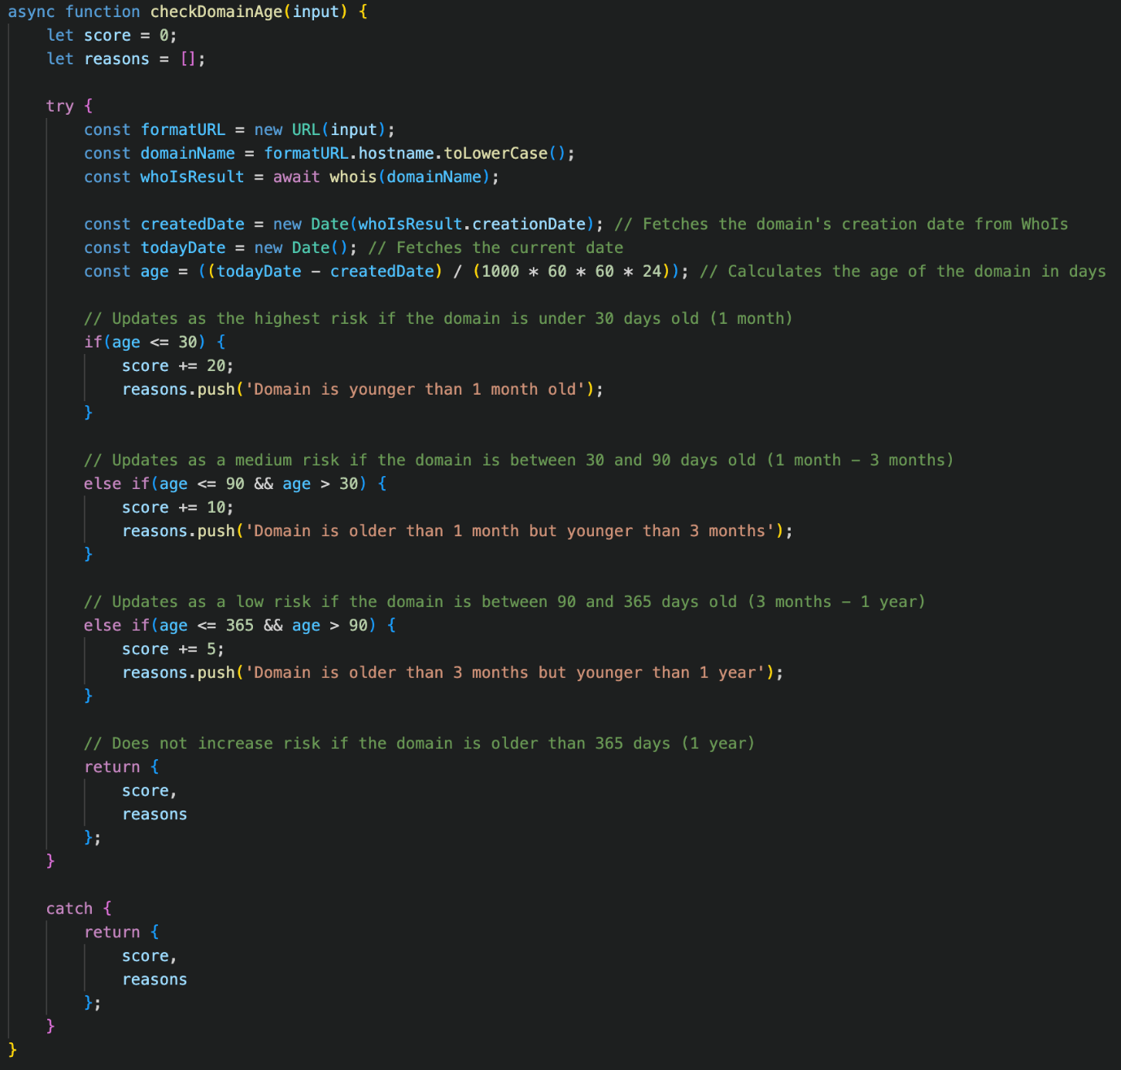
Security Header Check
Figure 12 – The checkDomainAge() function integrated in Visual Studio Code
Before a site is loaded, the HTTP headers are fetched, and the risk score is increased based on which security headers are missing, with different headers adding different weighting based on importance as some headers are used in specific contexts. Figure 12 shows the code for the function ‘checkSecurityHeader()’, which compares against a list of all currently utilised security headers. Table 2 shows each of the headers involved in this check and their relevance for security of a website, along with drawbacks for those that have them.
Table 2 – Security Headers Checked
Header | Score Adjustment | Reason | Drawbacks
x-frame-options | +5 points | Used to avoid clickjacking attacks by ensuring content is not embedded into other sites | Only useful when there is something to interact with i.e., a link or a button
x-xss-protection | +2 points | Stops pages from loading if a cross-site scripting attack (XSS) is detected | Can create XSS vulnerabilities in safe websites
x-content-type-options | +5 points | Used to block MIME type sniffing and MIME confusion attacks | N/A
referrer-policy | +2 points | Controls how much referrer information should be included with requests | Default behaviour is to no longer send all referrer information to the same site
strict-transport-security | +10 points | Instructs access to be only via HTTPS even if HTTP is attempted by the user | Misconfiguration may lead to a legitimate user being blocked from the website
content-security-policy | +10 points | Detects and mitigates attacks including XSS and data injection attacks | Meaningless if REST API returns content that will not be rendered
cross-origin-opener-policy | +2 points | Protects against attacks like Spectre | N/A
cross-origin-embedder-policy | +2 points | Prevents a document from loading cross-origin resources that don’t grant the document permission | Enabling will block cross-origin resources not configured correctly from loading
cross-origin-resource-policy | +2 points | Blocks a given response before entering an attacker’s process | N/A
permissions-policy / feature-policy | +2 points | Allows features to only be enabled in the current document or frame if it matches the list of allowed origins | N/A

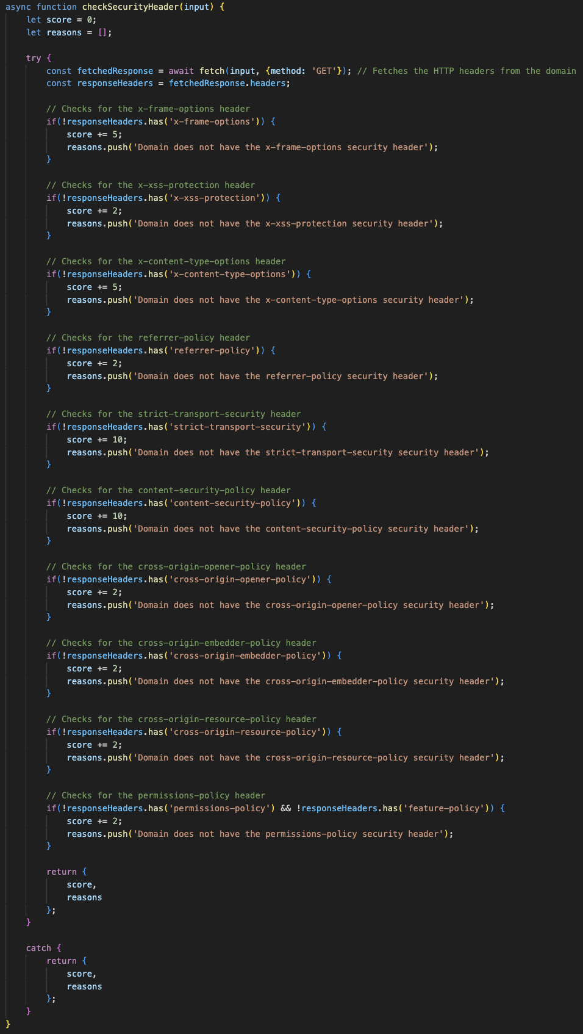
Figure 13 – The checkSecurityHeader() function integrated in Visual Studio Code

Typosquatting Check
Typosquatting involves masking a malicious URL to look like a legitimate one, by exploiting misspellings of common domains. The Talisman package was used to create a typosquatting check, utilising the built-in Damerau-Levenshtein function to determine the distance between the entered URL and a list of common URLs. The risk score is then increased depending on how close the domains are, increasing by 30 points if the domain is one step away, and by 15 points if the domain is two steps away. This utilises only the closest distance to prevent the score being increased multiple times from checking multiple domains, The domain was split to extract subdomains, which allowed checks to be performed on each subdomain to analyse its distance. If the URL matches exactly, the function is not called to prevent any false positives from being created and access to a legitimate domain being blocked. Figure 13 shows the code for the function ‘typosquattingCheck()’.
The Talisman package was used to import the Damerau-Levenshtein algorithm, which was chosen over other packages due to it containing the largest library for comparison. Additionally, when compared to other algorithms such as fast-levenshtein or js-levenshtein, Damerau-Levenshtein is the most optimal for detecting swapped letters between domain names.

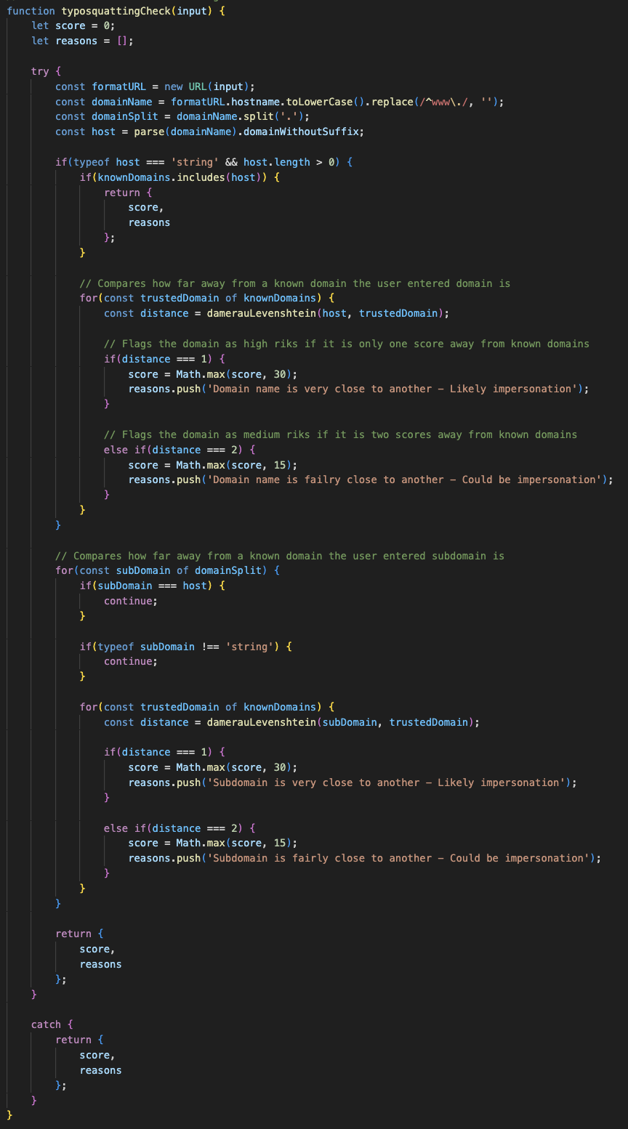
Figure 14 – The typosquattingCheck() function integrated in Visual Studio Code
Figure 15 – The riskScore() function integrated in Visual Studio Code

Implementation

Features
This section details the features that were implemented into the final project. The features are focussed primarily on security due to the nature of this project, with explanations as to why they are necessary for the final implementation.

Session Only Cookies
To allow for full privacy to be kept, Stronghold automatically deletes cookies once the browser is closed and the session has ended. This means that cookies are not stored, which can assist in mitigating the damage from an attack which relies on stealing cookies, as only cookies from the current session will be available – This could include a cookie scraper, which would take a user’s cookies, including login tokens that would enable unauthorised access to that user’s sessions for malicious purposes.
This feature has been fully implemented in the final product. Initially, this feature was intended to be customisable from within the settings menu, allowing the user to decide whether it should be enabled or not. This was changed in the final implementation to ensure guaranteed deletion for security purposes. This could however lead to user irritation, due to not being able to save logins, and having to accept website cookies on every visit.

Cookie Export Authentication
Exportation of cookies was a potential vulnerability identified against this project, as this could lead to session tokens being stolen which can then allow for malicious access into user’s accounts. While session only cookies were implemented as an attempt to stop this, having authentication being needed to export these cookies could act as an extra layer to mitigate the opportunity for these attacks to succeed.
The initial design for this feature was to work alongside the toggle for enabling cookies. However, since this was never implemented and was instead changed to always delete cookies at the end of a session, authentication for exporting was never implemented. This was initially planned as a stretch goal and was deemed as unnecessary based on how cookie handling was implemented.

Blocking of Non-HTTPS Sites
Due to the nature of HTTP sites not containing relevant security features, this project initially involved a block on all HTTP sites to allow for an improvement in security. This aimed at reducing the risk of users accessing websites that could lead to plaintext interception of confidential details such as login details, although this resulted in blocking many legitimate sites where high security is not deemed necessary due to the nature of the site.
While not implemented as initially planned, HTTP blocking was involved as part of the risk blocking system that had been developed for this project. The final implementation allowed for HTTP-based sites to still be accessed by the user while increasing the risk score. This meant the site would only become blocked assuming other aspects of the risk scoring system were increased.

Blocking Downloads
A security feature deemed necessary for this project is to block downloads of file extensions which could potentially be used for malicious purposes, and warning the user with an informative message to explain why. This includes extensions such as .exe, .msi, .cmd, and .zip. By blocking these types of extensions, this will prevent any accidental downloading of malicious files, especially with the target audience being children who do not fully understand the dangers of the internet.
This feature was implemented in the final design; however, it did receive some changes compared to the initial plan. Due to the how all extensions were treated the same and were automatically blocked, this led to a lot of legitimate files being blocked also, such as Microsoft Office downloads which utilise the .exe file extension. A change was made in the final implementation to accommodate this by allowing a selective toggle in the settings menu for multiple tiers of download blocking.
A user can select between the following levels: strict blocking, wherein all downloads with commonly malicious extensions are blocked; normal blocking, wherein certain extensions, such as .exe, .msi, .dmg, and .zip, are warned against, while others, such as .cmd, .ps1, .bat, and .js, are blocked; and warn only blocking, wherein all downloads with commonly malicious extensions are only warned against.

TLS Certificate Checking
TLS certificates are mandatory for HTTPS sites to prove they are trustworthy to access. As such, when a site has a poorly configured TLS certificate, this should be marked as high-risk. This project includes a check to ensure that a site has a correctly configured TLS certificate when the user attempts to access it and blocks the site if the certificate is not correctly configured. A misconfigured TLS certificate includes being expired, being for a different domain, and not being issued from an approved issuer. Assuming a site is supposed to have a certificate, this check is performed and either blocks or allows access to the site based on the status of the certificate, allowing the user to remain safe and clear of potentially malicious domains.

Security Based Hints
An initial plan was to have hints pop up as the user navigated the app, providing knowledge about certain security elements to teach the user about online safety. This would fit in with the initial objectives outlined at the beginning of this report. Instead, the feature has been implemented in a way where it is explained to the user why a site has been warned or blocked, but there are no pop-ups that appear generally as they browse.

Override Methods
Override methods were an essential feature to implement into this project, as this allows users to continue to a page or download that is deemed potentially malicious and therefore receives a warning by Stronghold.
This feature initially had been planned to require a parental control PIN or one time code to be entered to override the warning. Since these parental controls were never implemented, this was unable to happen so the final implementation includes a simple page with a warning and explanation as to why the block has taken place. The user can acknowledge this warning to continue, causing a small amount of experience loss, or the user can go back, causing a small experience gain.

Quiz System
One of the unique selling points of this project involved having quizzes that the user could complete for bonus experience, to reinforce their learning. The quiz system implemented involved both daily and weekly quizzes.
The daily quizzes could only be completed once per day and were only one question, rewarding 10 experience points to the user, and was chosen from a random list of set questions. The final implementation included 5 questions stored in Firebase; however, this would be expanded in the future.
The weekly quizzes could only be completed once per week and were 10 questions long, rewarding 5 experience points per correct question to the user. These were also chosen at random from a set list of questions. The final implementation included 10 questions stored in Firebase; however, this would be expanded in the future. This has meant that the questions are all the same but in a random order for this final implementation.

Guest Browsing
Guest browsing was implemented as an additional security measure, to allow users access who do not wish to input an email address or sign in to their Google account. This feature involved blocking access to the settings menu and dashboard, requiring a sign in to be able to access these, since guests were restricted to the most basic, strictest forms of download and URL blocking.

Security Dashboard
A centralised security dashboard was implemented to inform users of their browsing habits and contain elements relating to the gamification of the browser. This dashboard acted as a unique selling point for the browser, providing both learning elements and security statistics. Users were able to view their five most recent blocked sites and blocked downloads, as well as recent ignored warnings. The dashboard also showed gamification elements which included one daily question and ten weekly questions, experience amounts, and recent experience changes that the user received.

Firebase
This means that, instead of a separate account needing to be created specifically for Stronghold, users can instead use an existing Google account to sign in.
This does have a limitation of users needing to create a Google account if they do not possess one already, which may not be liked by some users, however, is necessary to ensure complete security of the user’s account.
The database should be used to store only basic information about the user, and any simple information which is needed for browser features to work. The following features were initially deemed as necessary:
    - Username / User ID:
        - This is used to determine the specific user who is logged in
    - XP Amount:

    - XP History:

    - Level:

    - Safe Day Streak:

    - Sites Blocked:

    - Downloads Blocked:

    - Warnings Ignored:

    - Cookies Deleted:

    - Appearance:

    - Search History:
        - Enabled
        - Disabled

    - Cookies:
        - Cleared
        - Not Cleared

    - Quiz Information:
        - Questions
        - Answers

    - Parental Control PIN:

    - Challenges:

    - Timestamps:
        - Creation Date
        - Last Login

Certain additions were made to the database throughout creation as more details were needed to be stored and more settings were added to create a more customisable feel. These additional settings include:
    - Protection Level:

    - Download Blocking Level:

    - Start Page:

LSEP Considerations
This section will discuss the legal, social, ethical, and professional issues which needed to be considered throughout the creation of this project to ensure this project did not break any laws, remained ethical throughout its creation, and could remain suitable for everyone and conform to societal and professional industry norms.

Legal Issues
Avoiding breaches of GDPR was an issue that needed to be addressed throughout the creation of this project, as doing so could have resulted in significant financial penalties. This was ensured by collecting minimal data which was stored inside Firebase and not shared outside of the scope; only the user’s username and data about Stronghold was collected. Furthermore, a privacy policy was implemented to outline to the user what data would be collected, how it would be stored, and what would happen to it. The user was also provided with an option to delete their account, and therefore their data, from within the settings menu.
Additionally, licensing issues needed to be addressed. With a variety of libraries being used to develop this project, it was essential to ensure they had valid licenses that would allow free use. This guaranteed there would not be any issues with the necessary libraries for this project to work. Any breach of licensing terms could lead to lawsuits from the developer of the library; therefore, it was imperative that only free use libraries were used.

Social Issues
Accessibility needs were considered throughout development of this project. These features would need to allow for a variety of accessibility needs to be met, including vision-based disabilities and learning disabilities. Using simplified language was suitable to assist people with learning disabilities by helping them to learn without being too imposing and creating frustration with the app. Contrasting colours were considered to assist users with vision-based disabilities which needed to be balanced with colours emitting a secure feeling. The final design was deemed as suitable for this, with an option considered for high contrast; however, this was not implemented in the final project.
Furthermore, it was essential to keep the browser age appropriate since it was developed with children as target audience. This was accomplished by using child-friendly language across educational segments which included simplifying more complicated theory to assist with learning and not using fear-based language which may cause more damage to online education than warranted.

Ethical Issues
Testing this project created some ethical issues, particularly when considering testing against the target audience. Due to the target age group involving children, there was no ethical way to accurately test against them, therefore it was slightly inaccurate due to being performed away from the target audience. Parents were considered to determine if they would allow their children to use the browser, however this required ethical consent from the university to perform.
Gamification caused some ethical concerns as it needed to be implemented without encouraging unhealthy behaviour such as negative competition or addiction. This was accomplished by keeping all gamified aspects simple and with limited repetition, such as having the quizzes be non-repeating within a specified length of time, either daily or weekly depending on the quiz. Additionally, the lack of cosmetic rewards adds to lowering the competitive elements, although this would be a feature considered for future implementation and therefore would require further ethical analysis.

Professional Issues
Professional considerations focussed primarily on formal coding practices and clean documentation. These included using clear comments to accurately explain the code, using version control throughout development, and keeping documentation clear and concise. This has been accomplished by commenting functions carefully to explain the tasks they perform, using GitHub Desktop to create a version history of development by pushing changes consistently, and documenting the creation process without repetition, spelling or grammar mistakes, and in an organised fashion.

Project Management

Sprints
This section outlines details of the sprints that took place throughout development of this project. Each section will outline the aims of the sprint, and whether those aims were achieved or not. Screenshots of the Trello board for each sprint can be found in Appendix X.

Sprint 1
Sprint 1 was the main planning sprint, where the project objectives were outlined and the initial designs were made. This acted as a baseline plan for this project before development was able to begin.

Sprint 2

Sprint 3

Sprint 4

Sprint 5

Sprint 6

Sprint 7

Trello
Trello was the project management tool used to plan each sprint at the beginning of development and explain what was performed once each sprint had finished. While the initial plan was not stuck to for each sprint, Trello was still useful at tracking which features had been worked on or implemented in these sprints.

GitHub Desktop
GitHub desktop was the software used throughout development to create a history of the different versions of this project. This was useful when changes needed to be reverted due to bugs or changes suggested after user testing and was also beneficial to understand what was performed throughout each sprint.
Using a standardised naming scheme was helpful to establish professionalism throughout, although this was not always necessarily followed, as was descriptions of what changes were being made with each commit.

Testing and Evaluation
This section will detail the testing methodology, including who was chosen and why, what kind of tests were performed, what feedback was provided from participants, and how the provided feedback was used to make improvements to the project.
- Will get several people to test the browser and answer a Google Form with a variety of questions to get an understanding of what they like and what should change
- Test both initial wireframes (so I can change before proper development begins), and with the final design (so I can make changes before the VIVA and final presentation)
- Form will be tested majority using other students; however, I may also use some non-student friends, family members etc. to get a full, diverse response pool
- Testing form needs to include a declaration to state that respondent is happy for their answers to be included for the purpose of this document and the final submission

Testing Methodology

Functional Testing
After each development phase, testing was performed on the features implemented to ensure they functioned as intended. Table 3 details the testing process, explaining what outcome was expected from the testing, and what outcome was provided. If these matched, the feature was classed as passing testing, and if they did not match then the feature was classed as failing testing.
Table 3 – Functional Testing Requirements
Test Performed | Expected Outcome | Real Outcome | Result
Safe URL entered | Site loads | Site loaded | Pass
Risky URL entered | Warning URL page is displayed | Warning URL page was displayed | Pass
Malicious URL entered | Blocked URL page is displayed | Blocked URL page was displayed | Pass
Safe download attempted | Warning download page is displayed | Warning download page was displayed | Pass
Malicious download attempted | Blocked download page is displayed | Blocked download page was displayed | Pass
Browse as a guest | Strict browsing mode is enabled and access to dashboard and settings page is blocked | Strict browsing mode was enabled and access to dashboard and settings page was blocked | Pass
Sign in | Google OAUTH popup appears | Google OAUTH popup appeared | Pass
Delete account | Account is deleted from Firebase | Startup page was displayed and account was deleted from Firebase | Pass
Complete daily quiz once | Relevant XP is awarded and further access is blocked | Relevant XP was awarded and further access was blocked | Pass
Complete daily quiz twice | Cannot access | Could not access as button was disabled | Pass
Complete weekly quiz once | Relevant XP is awarded and further access is blocked | Relevant XP was awarded and further access was blocked | Pass
Complete weekly quiz twice | Cannot access | Could not access as button was disabled | Pass
Click forwards button | Navigates forwards | Navigated forwards | Pass
Click backwards button | Navigates backwards | Navigated backwards | Pass
Click refresh button | Refreshes page | Refreshed page | Pass
Click home button | Navigates to the home page | Navigated to the home page | Pass
Click dashboard button | Navigates to the dashboard | Navigated to the dashboard | Pass
Click settings button | Navigates to the settings page | Navigated to the settings page | Pass

User Testing

Evaluation

Future Implementations

DNS Check
The initial plan for the risk score involved performing a DNS check on URLs that a user had attempted to access. This was planned as utilising a free online DNS checking tool to determine the safety of the domain by analysing if it is maliciously hosted, has a constantly changing IP address, or has missing DNS records. It was decided to not implement this feature as part of the risk score due to the integration required with an external source, and potentially reanalysing the domain for elements that the risk score already checks for, potentially falsely blocking domains. This remains as a feature for future implementation if an external source can be effectively utilised without causing repeat increases to the risk score.

Redirect Analysis
The initial plan for the risk score involved checking the number of redirects used in a URL to prevent a legitimate URL from redirecting to a malicious URL. Each redirect would be intercepted, with the risk score increasing exponentially per redirect used. This function was never implemented due to…

Parental Controls
Parental controls were considered to add an extra level of security for children who may be using this project. The initial design for parental controls was to have the user enter their date of birth upon account creation and requiring another sign in if detected as under 13 years old. After some consideration, it was decided that this needed to be changed since children could simply lie about their age or sign in with a separate Google account acting as the parent, both of which would negate this feature. Requiring an additional sign in would then have caused complications within Firebase due to having to link multiple Google sign in states together.
The workaround to this issue was to add a button in the settings menu, or prompted on first login, to add a PIN which would then be requested upon an attempt to change any security-based setting, such as changing the selected risk score algorithm or download blocking level. This had the same consideration however that the child may potentially set the PIN up themselves, or figure out what the PIN is, making the feature negligible.
This feature was not implemented in the final design due to the decision that it would not have the desired effect, and complications with linking the PIN to Firebase. This has meant that in the final implementation, there is no filter to prevent the settings from being changed undesirably as initially planned, potentially causing a loss in security.

AI Chatbot
An AI chatbot was considered for implementation as a stretch feature, which would act as a cyber security advisor. The plan for this feature involved allowing the AI to scan the page to confirm if URLs could potentially be malicious, both from web searches and in emails, as well as being able to answer user’s questions. The Gemini API was considered as a solution for implementing this feature, however it was not implemented due to time and difficulty constraints.

Built-in VPN
A built-in VPN was considered as an additional stretch feature for implementation. This would have involved integrating a free VPN provider to allow for use from within Stronghold, allowing for the additional security which VPNs provide. This was not implemented in the final project due to the high level of complexity and time required, and it being outside of the scope of the project.

Conclusion

References
- https://www.w3schools.com/html/default.asp
- https://www.w3schools.com/css/default.asp
- https://www.w3schools.com/js/default.asp
- https://www.electronjs.org
- https://www.electronjs.org/docs/latest/
- https://stackoverflow.com/questions
- https://firebase.google.com
- Firebase Documentation
- https://www.npmjs.com/package/talisman?activeTab=versions
- https://github.com/yomguithereal/talisman
- https://www.zscaler.com/blogs/security-research/phishing-typosquatting-and-brand-impersonation-trends-and-tactics
- https://cheatsheetseries.owasp.org/cheatsheets/HTTP_Headers_Cheat_Sheet.html
- https://www.usenix.org/legacy/event/sec09/tech/full_papers/sunshine.pdf
- https://dl.acm.org/doi/epdf/10.1145/3025453.3025896
- https://pmc.ncbi.nlm.nih.gov/articles/PMC7751389/pdf/fpsyg-11-528079.pdf
- https://www.researchgate.net/publication/324659530_An_Experience_Sampling_Study_of_User_Reactions_to_Browser_Warnings_in_the_Field
- https://www.verizon.com/business/resources/T6ac/reports/2024-dbir-data-breach-investigations-report.pdf
- https://www.ncsc.gov.uk/collection/device-security-guidance/policies-and-settings/managing-web-browser-security
- https://www.zscaler.com/blogs/security-research/phishing-typosquatting-and-brand-impersonation-trends-and-tactics
- https://www.ofcom.org.uk/siteassets/resources/documents/research-and-data/media-literacy-research/children/children-media-use-and-attitudes-2024/childrens-media-literacy-report-2024.pdf
- https://safebrowsing.google.com
- https://support.mozilla.org/en-US/kb/how-does-phishing-and-malware-protection-work
- https://help.opera.com/en/latest/security-and-privacy/
- https://learn.microsoft.com/en-us/windows/security/operating-system-security/virus-and-threat-protection/microsoft-defender-smartscreen/

Appendices

Appendix A – Design Screenshots

